# Report for TJ Cole-Hines (2024-10-01 to 2024-10-31)

Average Bat Speed: 56.56

Average Rotational Acceleration: 13.73

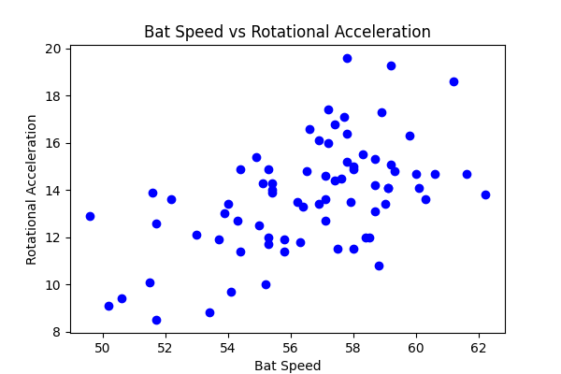

## Comments

Add comments here...